PROJECT DOCUMENTATION
PocketSmart AI
AI-Powered Budget Planning Application
FastAPI · Gemini AI · JWT Auth · Jinja2

1. Introduction
Project Title: PocketSmart AI:your smart budget & Recommendation Assistant
Team Leader: Nandhini.M (nandhini.m.25ds026@gmail.com)
Team Members:
- Amrin.J (amrin.j.25ds004@gmail.com)
- Pooja Shri.R (pooja.shri.r.25ds031@gmail.com)
- Yakshitha.M (yakshitha.m.25ds049@gmail.com)

2. Project Overview
PocketSmart AI is a FastAPI web application that helps users plan budgets for home purchases, parties, and jewelry using AI-generated recommendations.
It combines a FastAPI backend, HTML/Jinja2 templates, authentication, budget input models, Gemini AI recommendations, optional image analysis for jewelry planning, and shopping links.
The application currently uses in-memory storage for users, blacklisted tokens, and recommendation history.

3. Technology Stack
Layer | Technologies
Backend | Python, FastAPI, Uvicorn
Frontend | HTML templates rendered with Jinja2
AI | Google Gemini integration
Authentication | JWT tokens, HTTP-only cookies, Passlib bcrypt
Image processing | Pillow
Configuration | python-dotenv

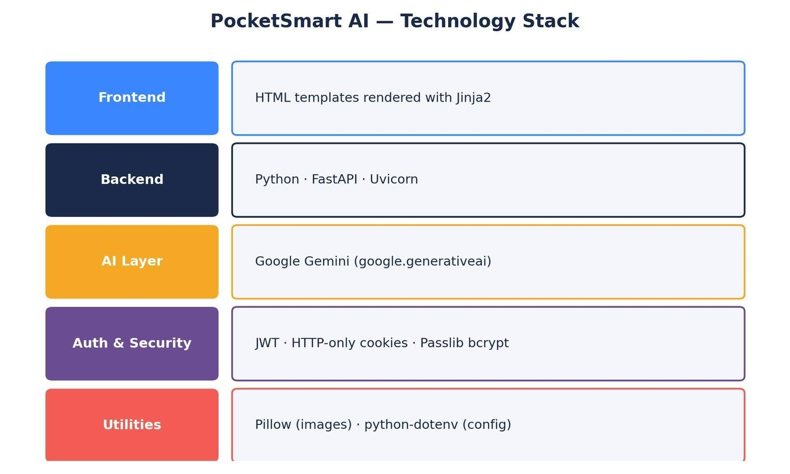
Figure 1 — Technology stack by layer

4. Project Structure
File / Folder | Purpose
app.py | FastAPI application, routes, forms, uploads, history
auth.py | Password hashing, JWT creation/validation, cookies, blacklist
gemini_utils.py | Gemini configuration and AI recommendation functions
models.py | Pydantic request / data models
templates/ | HTML pages
static/ | Static resources and uploaded images
.env | Environment configuration
requirements.txt | Python dependencies
README.md | Setup and run instructions

5. Application Architecture
The browser sends requests to FastAPI. FastAPI validates input and authentication, calls the appropriate planner function, and renders HTML responses. Planner functions send structured prompts to Gemini, extract JSON responses, add shopping links, and return recommendations.
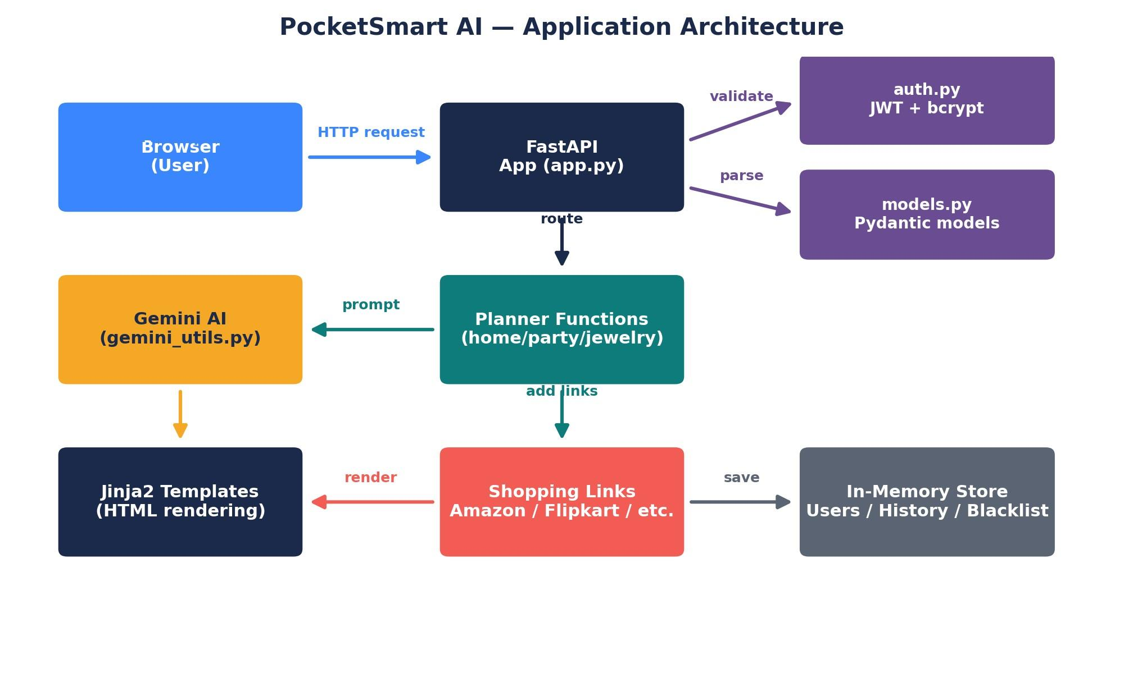
Figure 2 — End-to-end application architecture

6. Registration & Authentication
- Registration accepts username, email, and password.
- Passwords are hashed with bcrypt before storage.
- Login authenticates the user and creates an HS256 JWT stored in an HTTP-only access_token cookie.
- Protected routes validate the token, check expiration and blacklist status, and identify the authenticated username.
- Logout blacklists the token and deletes the authentication cookie.

7. Dashboard
The protected dashboard displays recent history records. The current implementation retrieves the latest five records for the logged-in user.

8. Home Budget Planner
Accepts total budget, quantities for lights, fans, furniture, and dining tables, room information, and additional requirements.
The Gemini prompt is designed for India and INR budgets and requests structured recommendations within the supplied budget.
Configured shopping platforms include Amazon India, Flipkart, IKEA India, and Myntra.
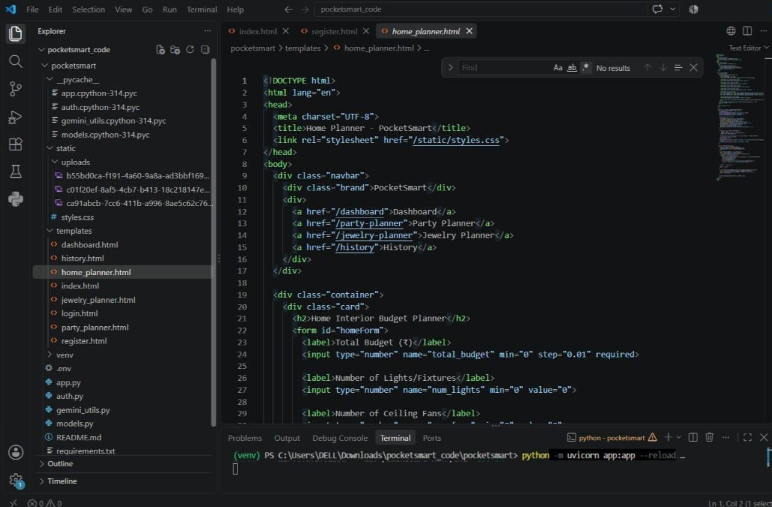

9. Party Budget Planner
Accepts budget, guest count, party type, venue type, catering/decor/entertainment requirements, and additional requirements.
Recommendations include budget-aware costs and configured shopping/service links such as Amazon India, Flipkart, Swiggy, Zomato, and BookMyShow.
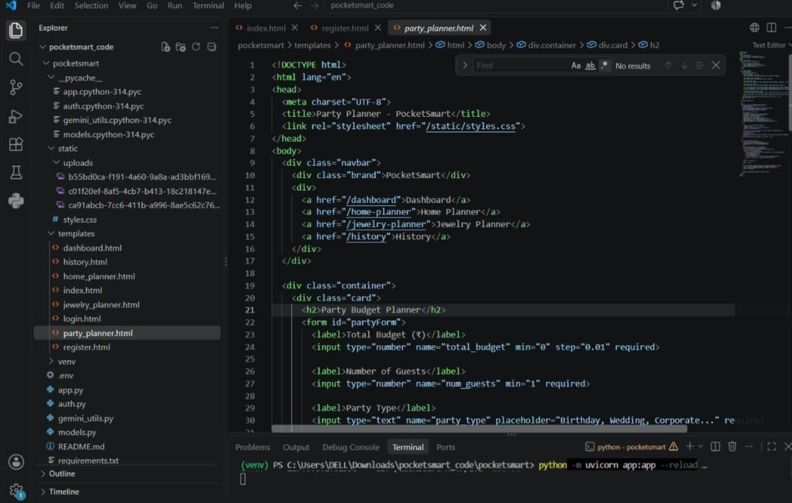

10. Jewelry Budget Planner
Accepts budget, occasion, preferences, and an optional outfit image.
When an image is supplied, the application saves it locally and passes it to the Gemini recommendation flow for visual analysis.
Configured shopping links include Amazon India, Flipkart, Tanishq, and CaratLane.
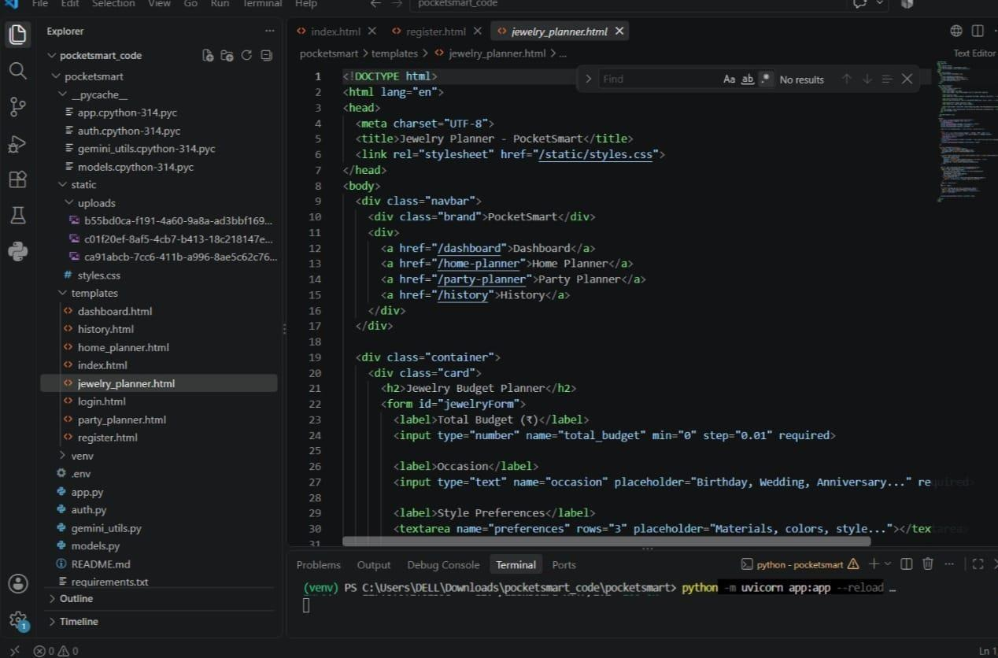

11. Gemini AI Integration
The current implementation imports google.generativeai, loads the API key from the environment, configures Gemini, and creates the configured model instance.
A helper extracts JSON from model responses so planner results can be processed as structured application data.

12. API Routes
Method | Path | Description
GET | / | Landing page
GET | /register | Registration page
POST | /register | Create a user
GET | /login | Login page
POST | /login | Authenticate
POST | /logout | Logout
GET | /dashboard | Protected dashboard
GET | /home-planner | Home planner page
POST | /home-budget | Home planner submission
GET | /party-planner | Party planner page
POST | /party-budget | Party planner submission
GET | /jewelry-planner | Jewelry planner page
POST | /jewelry-budget | Jewelry planner submission
GET | /history | History page

13. Data Models
Model | Fields
RegisterUser | username, email, password
UserInDB | username, email, hashed_password
HomeBudgetInput | budget, item quantities, room flags, requirements
PartyBudgetInput | budget, guest count, party type, venue, service flags, requirements
JewelryBudgetInput | budget, occasion, preferences

14. Installation & Running
1. Create and activate a virtual environment
python -m venv venv venv\Scripts\activate
# Windows source venv/bin/activate # macOS /
Linux 2. Install dependencies
pip install -r requirements.txt
3. Configure environment variables in .env
4. Run the app python -m uvicorn app:app --reload 5. Open in the
browser http://127.0.0.1:8000
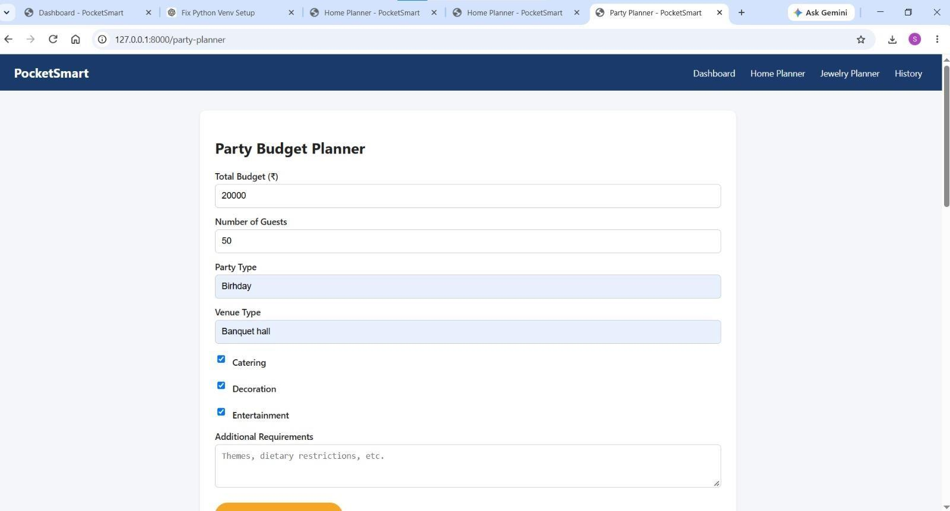

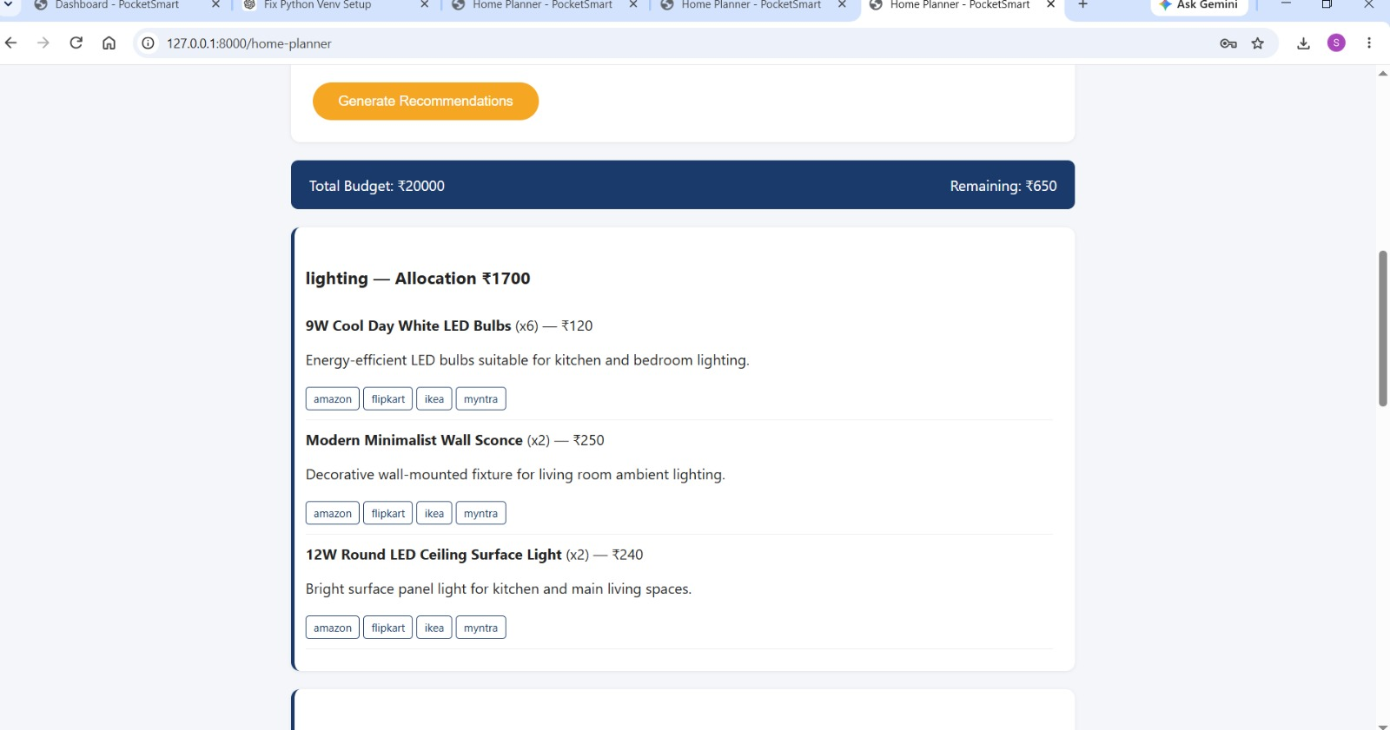
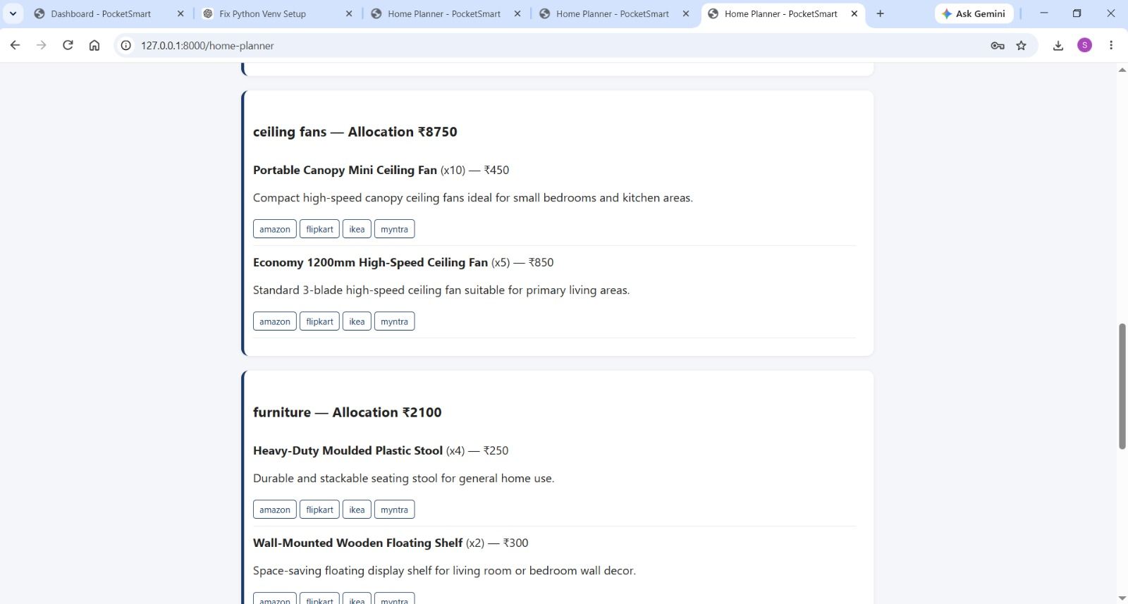
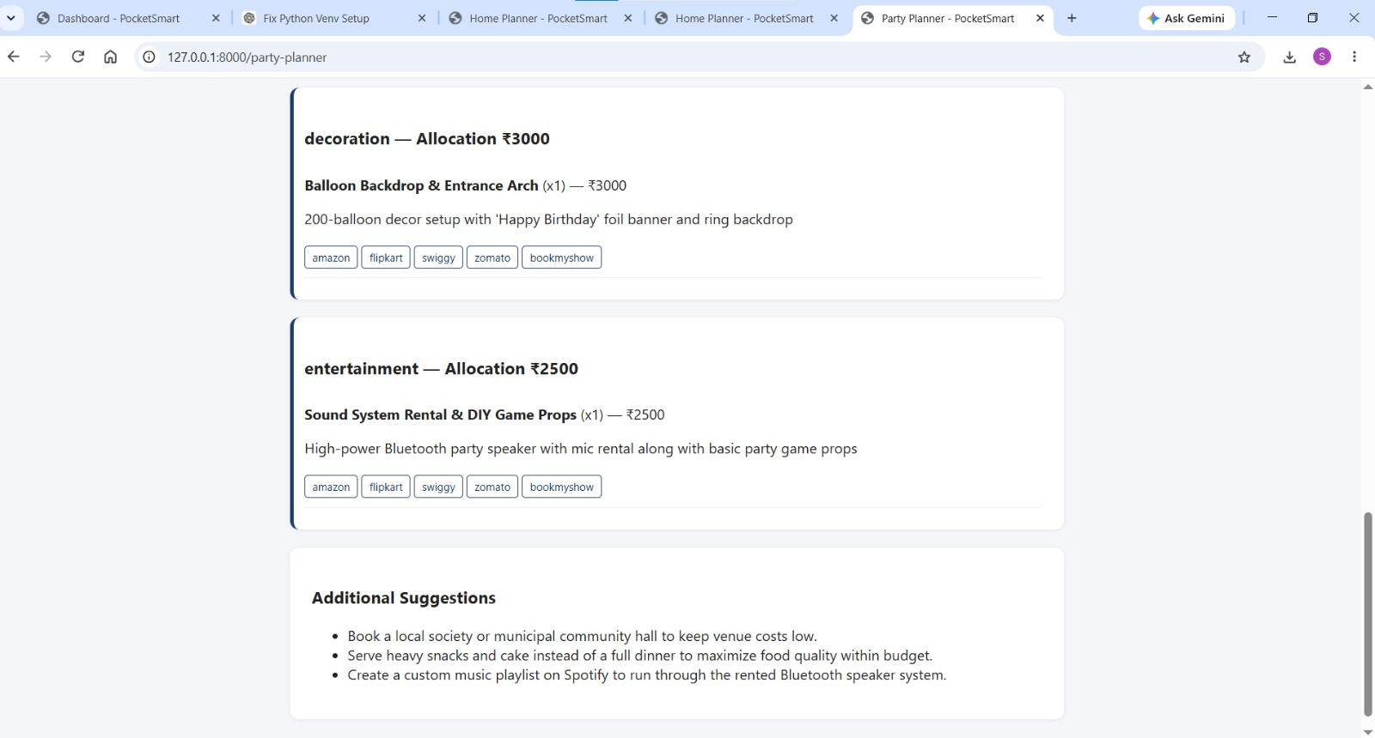

15. Environment Configuration
Variable | Purpose
GOOGLE_API_KEY | Gemini API credential
SECRET_KEY | Secret used to sign JWT access tokens
Credentials should remain private and should not be committed to public repositories.

16. Current Limitations
- User accounts and history are stored in memory, so data is lost when the application restarts.
- The current Gemini integration uses the older google.generativeai package.
- CORS is currently configured to allow all origins.
- Production use would require persistent storage, stronger configuration, robust error handling, secure secret management, and additional validation.

17. Suggested Future Improvements
- Add persistent database storage.
- Migrate the Gemini integration to the current SDK.
- Restrict CORS to trusted origins.
- Improve validation and error messages.
- Add rate limiting and stronger production authentication controls.
- Add automated tests.
- Add production deployment configuration.

18. Conclusion
PocketSmart AI provides a modular foundation for AI-assisted personal budget planning. Its FastAPI backend separates authentication, data models, AI utilities, and route handling, while specialized planners support home, party, and jewelry workflows.
For production use, persistent storage, secure deployment configuration, updated AI SDK usage, stronger security controls, and comprehensive testing should be added.
Prepared from the PocketSmart AI project files and implementation details provided in the project documentation.
GitHub Link :
https://github.com/nandhinim25ds026-alt/PocketSmart-AI

